Kwong Yuet Michael Fadillah Wong

CSCI-B 455

1a) Use the csvread.m function to read the data from the Excel _le into a matrix. Be sure that

the columns of data in the matrix, match the columns of data in the Excel

file = csvread("in_class2_data.csv")

1b) The distribution for the data in the _rst two columns is unknown. Generate separate his-

togram plots, one for the data in the _rst column and the other for the data in the second

column. Based on the histograms, what family of distribution(s) best describes the two data

sets? Be sure to include this answer in your writeup or just display it to the screen.

col1 = histogram(file(:,1))

col2 = histogram(file(:,2))

%Column1 data is leaning towards -1, it is a gaussian normal distribution

%Column2 data is leaning towards 1, it is also a gaussian normal distribution

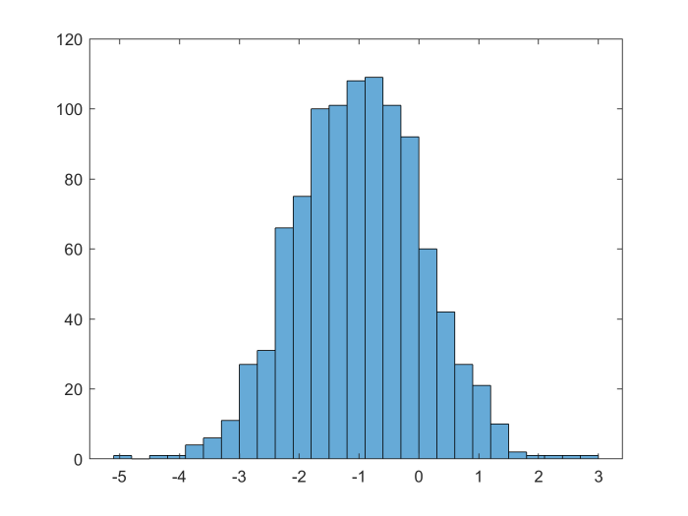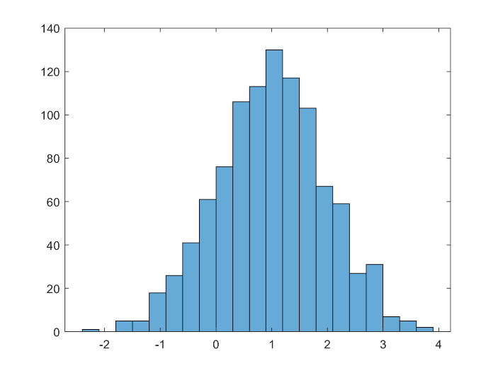

1c) Using the distribution from the previous part, estimate the expected values (e.g. E[X]) for the

data in the _rst two columns using maximum likelihood (ML) estimation. Look at the slides

on parameter estimation for details. Note that there should be an expected value for the _rst

column of data, and a separate expected value for the second column of data. Display the

expected values to the screen.

mleE1 = sum(file(:,1))/length(file(:,1)) %-0.9876

mleE2 = sum(file(:,2))/length(file(:,2)) %0.9876

1d) In a similar fashion, estimate the unknown variances (e.g. V ar[X]) for the data in the _rst

two columns using maximum likelihood (ML) estimation. Look at the slides on parameter

estimation for details. Use the estimated expected values from above to estimate variance.

Note that there should be a variance for the _rst column of data, and a separate variance for

the second column of data. Display the variances to the screen.

mleVar1 = sum((file(:,1) - mleE1).^2)/length(file(:,1)) %1.0927

mleVar2 = sum((file(:,2) - mleE2).^2)/length(file(:,2)) %0.9447

2a) For each data sample from the _rst column, compute the likelihood that it was generated from

H0 and from H1. Hence you should have two probability values for each sample from column

one. Hint: write a function that computes the probability from the given data sample, mean,

and variance. Use the distribution family that was indicated in question 1(b).

first = file(:,1)

like1 = []

for i = 1 :length(first)

like1 = [like1 ; likelihood_x(first(i))]

end

2b) Repeat the above step, but use data from the second column of the Excel.

second = file(:,2)

like2 = []

for i = 1 :length(second)

like2 = [like2 ; likelihood_x(second(i))]

end

definition for a and b:

function f = likelihood_x(x)

e1 = -0.9876

e2 = 0.9875

var1 = 1.0927

var2 = 0.9447

p1 = normpdf(x,e1,sqrt(var1))

p2 = normpdf(x,e2,sqrt(var2))

f(1) = p1

f(2) = p2

end

2c) Assuming uniform costs and equal priors, compute the likelihood ratio and compare it to

the likelihood ratio test, in order to classify each data sample from each column. Store your

decision (0 or 1) for each data sample of column one in a variable, and likewise store your

decision for the column two data samples in a separate variable. Hint: Use the `>' operator

to output 1 when the left-hand side is greater than the right-hand side, and 0 otherwise.

decision1 = []

for i = 1 : length(like1)

temp = like1(i,:)

left = temp(1)

right = temp(2)

decision1 = [decision1 ; right > left]

end

decision2 = []

for i = 1 : length(like2)

temp = like2(i,:)

left = temp(1)

right = temp(2)

decision2 = [decision2 ; right > left]

end

(results are shown in the matlab for Question 2a ,2b , and 2c)

2d) Compute the decision error (e.g. number of incorrectly classi_ed points divided by the total

number of points) for each column, considering that the _rst column of data should be

classi_ed as H0 (e.g. 0) and the second column of data should be classi_ed as H1 (e.g. 1).

Display these scores to the screen. Hint: It may help to use logic operators (e.g. `==' or

`~=').

error1 = 0

for i = 1:length(decision1)

if decision1(i) ~= 0

error1 = error1 + 1

end

end

derror1 = error1/length(decision1) = 0.166

error2 = 0

for i = 1:length(decision2)

if decision2(i) ~= 1

error2 = error2 + 1

end

end

derror2 = error2/length(decision2) = 0.157

2e) Use the decision errors from each column to compute the probability of error (e.g. P(E)).

Display this error to the screen. Hint: assume equal priors.

PE = (derror1+derror2)/2 = 0.1615